PE_PRN211_FA22_Trial  
FALL 22  
Subject: PRN211  
Duration: 90 minutes

**INSTRUCTIONS**

**Please read the instructions carefully before doing the questions.**

* You are **NOT allowed** to use any other materials. You are **NOT allowed** to use any device to share data with others.
* You must use IDE as **Visual Studio 2019 or later, MSSQL Server 2016 or** **later database** for your development tools.

**IMPORTANT – Before you start doing your solution, MUST do the following steps:**

1. To do your program, you must use **Windows Forms**. Using 3-Layer architecture. *Note that* *you are not allowed to connect direct to database from WindowsForms, every database connection must be used with Repository and Data Access Objects. The database connection string must get from appsettings.json file.* ***In the case your program connects directly to database from WindowsForms, you will get 0 mark.***
2. Create Solution in Visual Studio 2019/2022 named **PRN211PE_FA22_TrialTest_StudentName**. Inside the Solution, Project Windows Forms named: **ElectricStore_StudentName.**
3. Create your MS SQL database named **ElectricStoreDB** by running code in script **ElectricStoreDB.sql.**
4. Set the default user interface for your project as **Login** form.

Create an application using **Windows Forms** with .NET5/.NET6, C#, and ADO.NET (or Entity Framework Core). A MS SQL Server database will be created to persist the data and it will be used for reading and managing data.

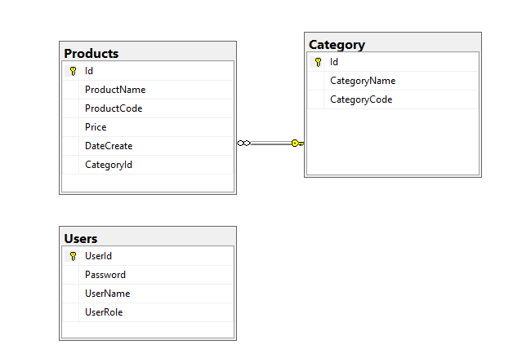A part of **ElectricStoreDB** database. User *role: Administrator = 1; Manager = 2; Staff = 3*

**Task 1. Design graphic user interface and project organize with 3-layer-architecture**1. (0.5 mark) Design login form includes UI controls for login function

2. (0.5 mark) Design management form, this form includes UI controls for CRUD actions with Products information. Note: the CategoryId/CategoryName will come from the Category table. Design a form that allows you to view the list of records, create a new item, update the existing item, and delete a specific record.

**Task 2. Implement CRUD actions with GUI**

3. (1 mark) Authentication function

If user with an Administrator role logs in successfully, save this information to a temporary parameter. All CRUD are required with authentication. In the case login unsuccessfully, display “Sorry, you are not allowed to access“

4. (2 mark) Check if login successfully, list all Products in the Products table.

5. (1 mark) Check if login successfully, search Product by ProductCode.

6. (1 mark) Check if login successfully, deletes the selected item with the confirmation then update the list of Product.

7. (2.5 marks) check if login successfully, add a new item (Product) with the requirements:

- The CategoryId/CategoryName will come from the Category table (you can use ComboBox UI control in this case)

- All fields are required.

- DateCreate in Create function will be automatically set today.

- DateCreate in Update function is not allow to change.

- Value for ProductCode is 4 characters, and all will be capital

- Value Price not allow <=0.

8. (1.5 marks) Check if login successfully, updates an existing item.